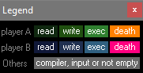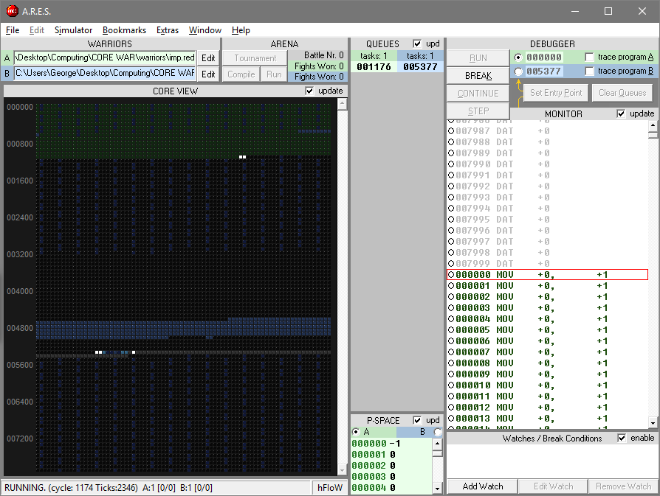Current Core War GUI’s for desktop

The ARES software is my preferred version of Core War, it has a simple layout and I like the colour coded display as it clearly shows which process is attached to which stats. The core display is also very clear to see which process is winning; the user can also request a key for the colours to tell which process is reading, writing etc.

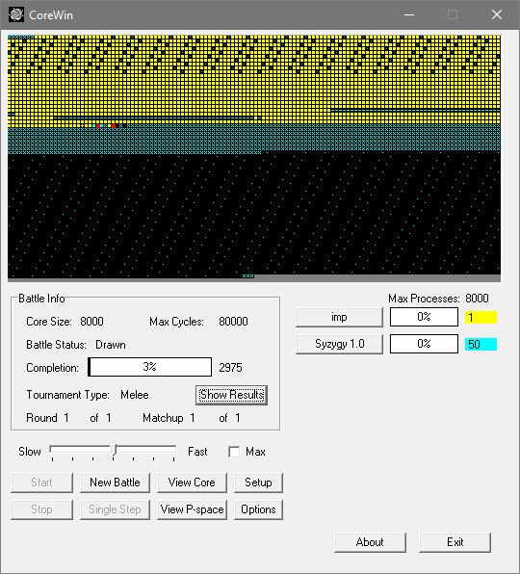

The CoreWin software is also quite clear, however there is a lot of wasted space and I think the core display is not quite as clear as other core war softwares. However I do like the way you can adjust the speed of the game so that if you don’t want to wait for the game to run you don’t have to.

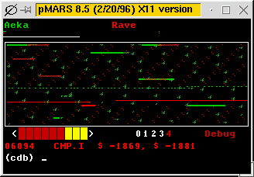

This is the pmars core war software, this is the worst display in my opinion as there are no buttons or controls displayed, the colour key is not very clear, and it is very difficult to tell which process is doing what in the core display.

Mobile GUI initial ideas

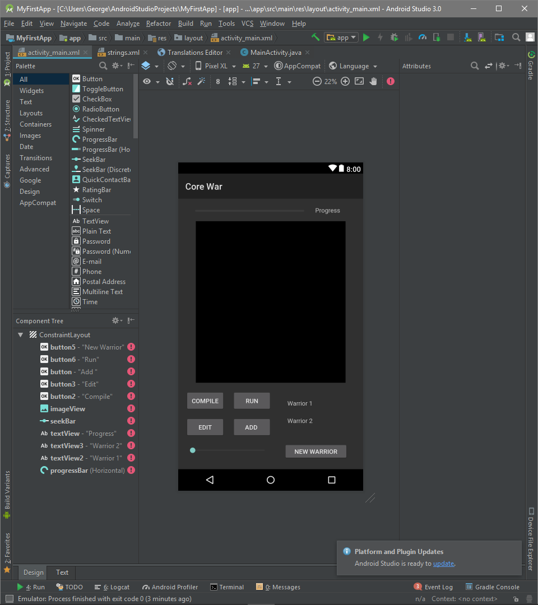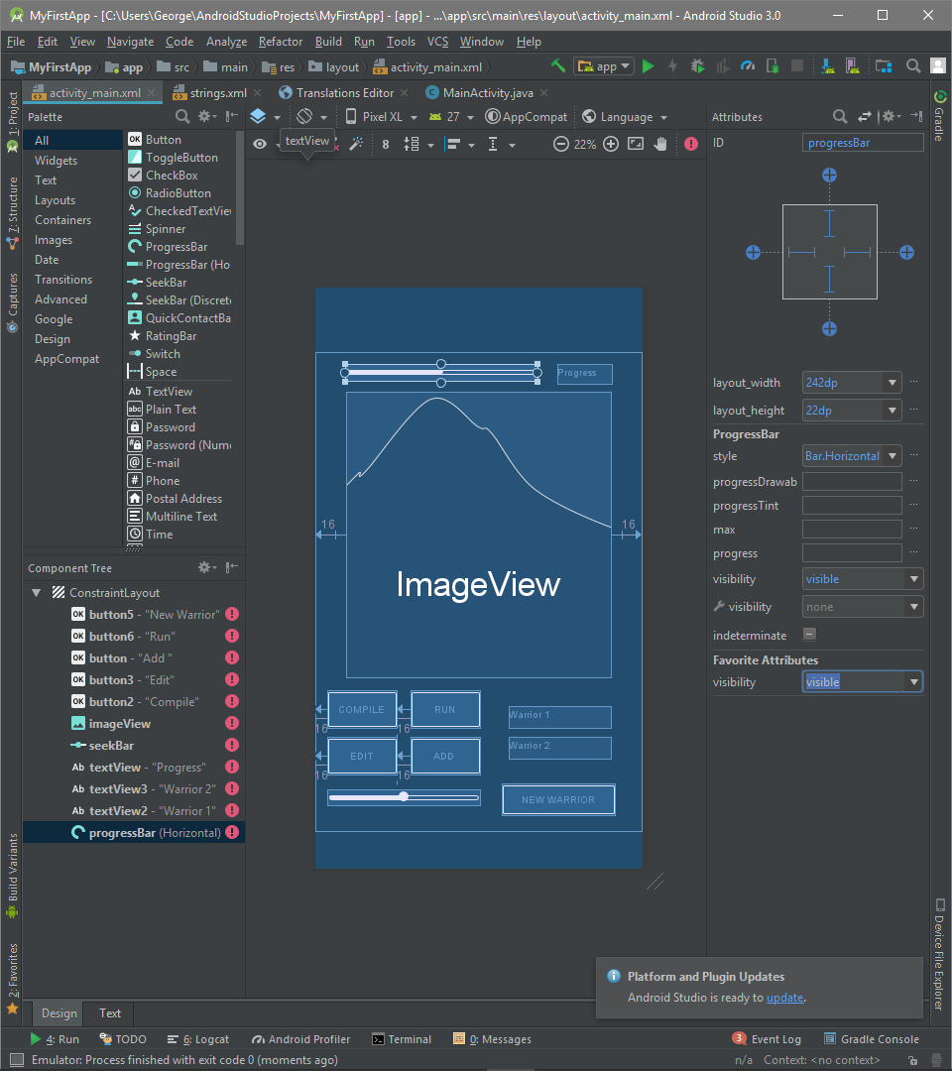

This is a very basic, design I made using Android sdk, this was just to get a rough idea of how the main page would look. The image view would be the core display, there is a progress of each battle at the top of the screen and there are multiple buttons to allow the user to add warriors, run battles etc.

The ‘NEW WARRIOR’ button would take the user to a new screen, allowing them to write Redcode for a new warrior. There is also a slider in the bottom left which would be used to adjust the speed of each battle.